A clustered index is a type of database index that determines the physical order of data rows in a table. It organizes the data in the table to match the index, meaning that the table's rows are stored on disk in the same order as the clustered index's key values.
In simpler terms:
- The data rows are sorted and stored based on the clustered index.
- A table can have only one clustered index because the physical order of the rows can only be arranged in one way.

Key Characteristics of Clustered Indexes
- Physical Sorting:
  - The data in the table is physically stored in the order of the clustered index key.
  - For example, if a clustered index is created on the column id, the rows will be physically ordered by id.
- Primary Key Default:
  - In many databases, if a primary key is defined, a clustered index is automatically created on the primary key column(s).
- Improves Query Performance:
  - Searching for data using the clustered index is faster because the data is stored in the same order as the index.
- One Per Table:
  - A table can have only one clustered index.
- B+ Tree Structure:
  - Most implementations of clustered indexes use a B+ Tree data structure, where the leaf nodes contain the actual data rows.

Example

Without Clustered Index:
- Data in the table is stored in an arbitrary order: | ID | Name | |------|---------| | 3 | Alice | | 1 | Bob | | 2 | Charlie |

With Clustered Index on ID:
- The data is stored in sorted order by the ID column: | ID | Name | |------|---------| | 1 | Bob | | 2 | Charlie | | 3 | Alice |

Advantages of Clustered Indexes
- Faster Data Retrieval:
  - Since the data is physically stored in order, retrieval operations (e.g., range queries) are faster.
  - Example: Queries like SELECT * FROM table WHERE id BETWEEN 10 AND 20 benefit significantly.
- Efficient Sorting:
  - Queries requiring sorted data do not need additional sorting operations.
- Better for Range Queries:
  - Clustered indexes optimize range-based queries (e.g., finding all rows where a column's value is within a certain range).

Disadvantages of Clustered Indexes
- Slower Write Operations:
  - Insert, update, and delete operations can be slower because maintaining the physical order of rows requires more effort.
- Only One Per Table:
  - Since a table can have only one clustered index, careful consideration is needed to determine which column should be indexed.
- Fragmentation:
  - Frequent updates or inserts can cause fragmentation, which degrades performance and requires periodic reorganization.
- Larger Index Size:
  - Clustered indexes are larger because they contain the actual data rows.

When to Use a Clustered Index
- Primary Key Columns:
  - Frequently used for querying and identifying rows uniquely.
- Columns with Range Queries:
  - Example: A column storing dates, where queries often involve ranges (WHERE date BETWEEN '2023-01-01' AND '2023-12-31').
- Columns Frequently Used in Sorting:
  - Example: Sorting customer names in alphabetical order.

Creating a Clustered Index
In SQL, you can create a clustered index explicitly or rely on the default behavior (e.g., for primary keys).

SQL Example: Explicitly Creating a Clustered Index


SQL Example: Creating a Table with a Primary Key (Implicit Clustered Index)


Clustered vs Non-Clustered Indexes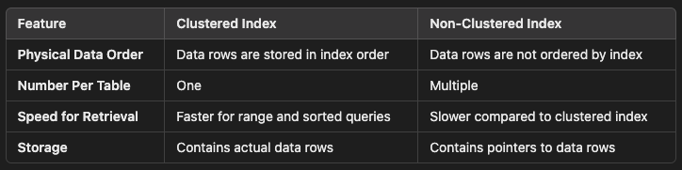

Conclusion
A clustered index is an efficient mechanism for organizing and accessing data in a table, particularly for queries that involve sorting or range lookups. However, the decision to use a clustered index requires balancing the benefits of faster retrieval with the potential performance impact on write operations.

